Emil: aakashsinghrajput8610@gmail.com
Name: Aakash Singh
Lab: Cache Poisoning
Tool Used: Burp Suite

Objective
To identify and exploit a web cache deception vulnerability to retrieve sensitive information (API key).

1. Test Credentials
Login with the Username: wiener
Password: peter
And you find the API key.
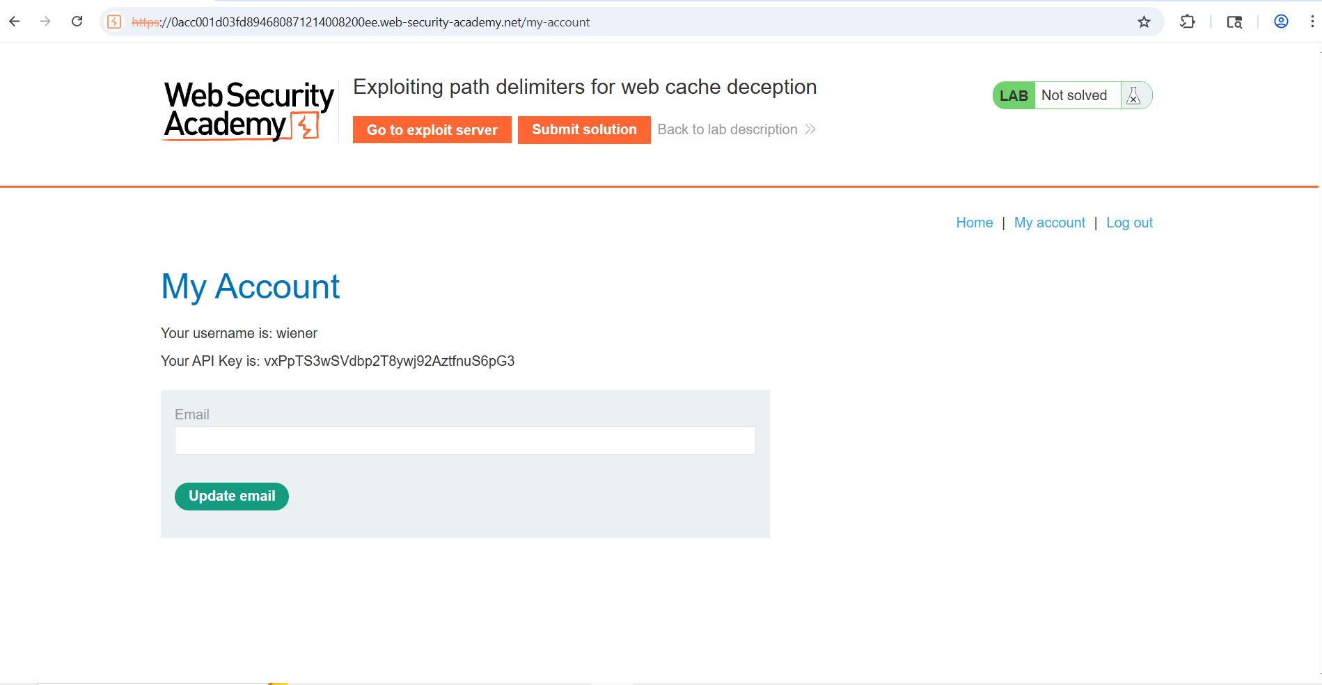

Step 2: Send Request to Repeater
- Go to Proxy > HTTP History.
- Right-click GET /my-account request → Send to Repeater.

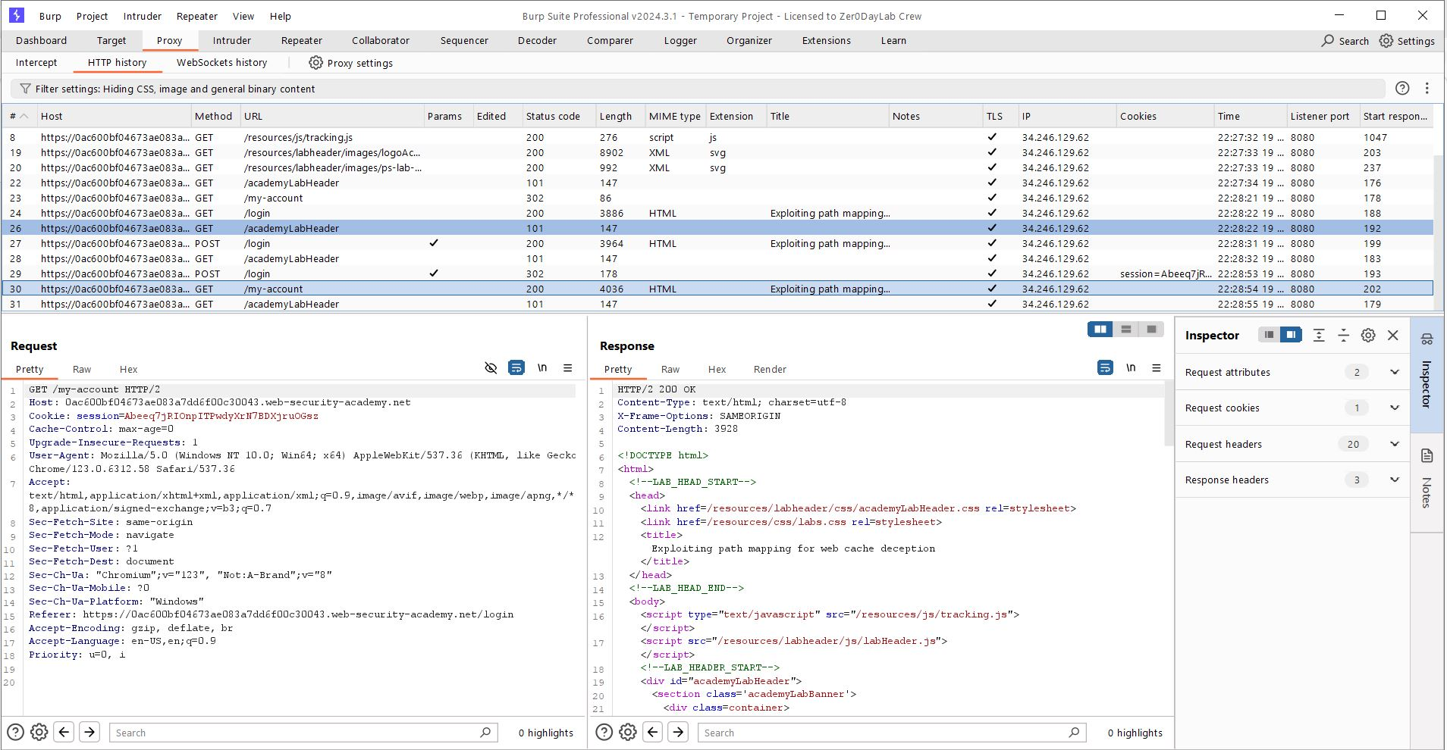

Step 3: Path Manipulation Test
- Modify path: /my-account/abc
- Send request → API key still visible.
- Conclusion: Server normalizes path to /my-account.
Static Extension Test
- Modify path: /my-account/abc.js
- Send request → Observe:
X-Cache: miss
Cache-Control: max-age=30
Cache Verification
- Resend request within 30 seconds.
- Observe: X-Cache: hit
- Conclusion: Response is cached due to .js extension.
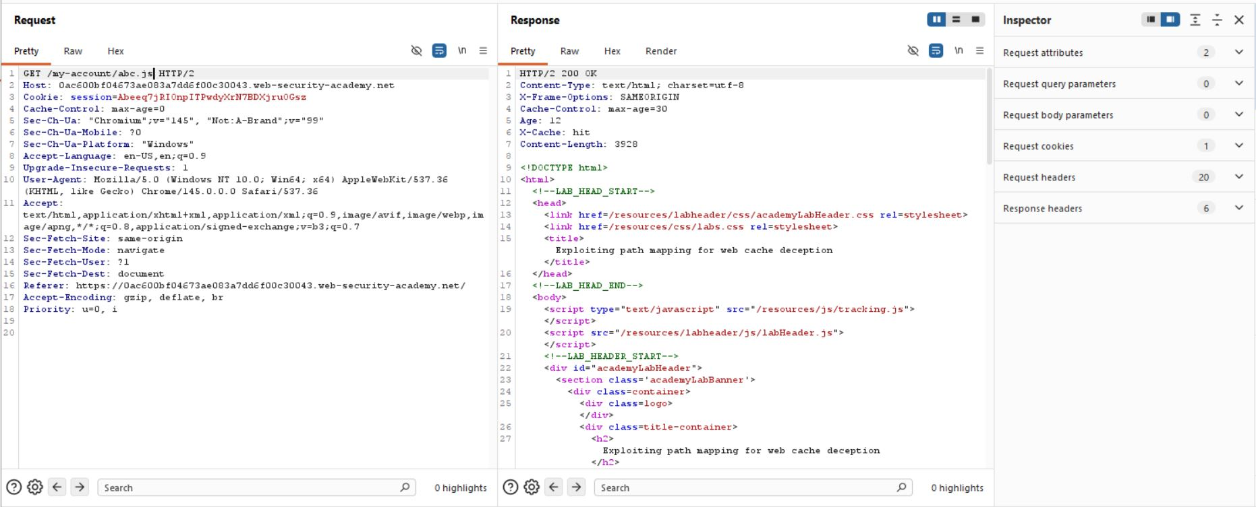
Step 6: Exploit Creation
- Go to Exploit Server.
- Add payload:
<script>document.location="https://0ac800bf04673dd6f00c30043.web-security-academy.net/my-account/wcd.js"</script> . Deliver Exploit and Click “Deliver exploit to victim”.
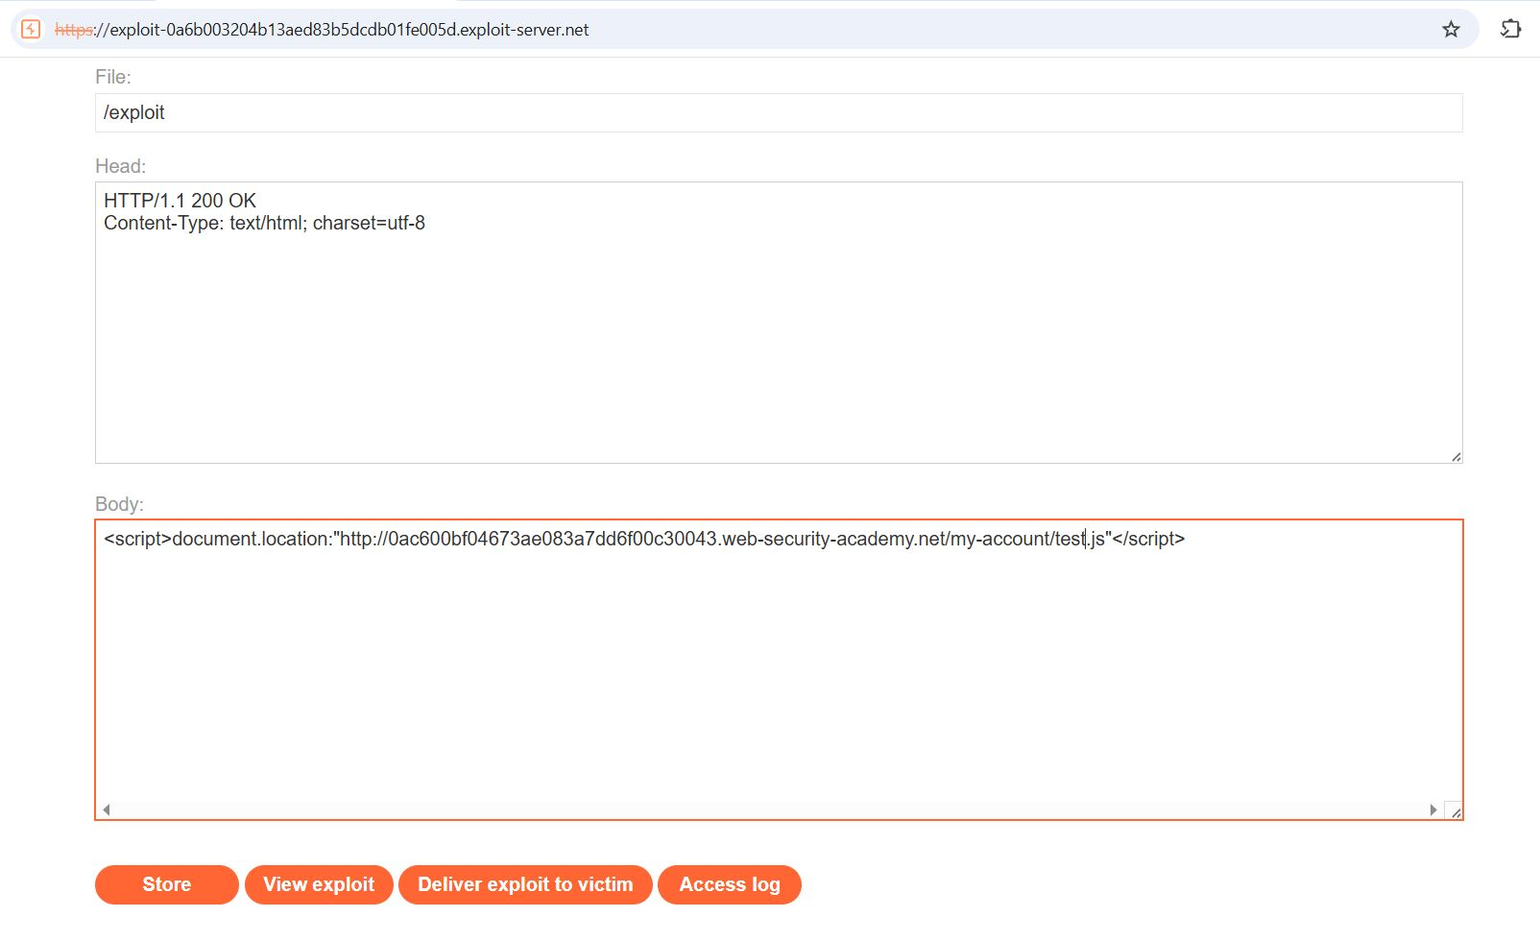
Step 8: Retrieve Victim Data
- Open:
“https://YOUR-LAB-ID.web-security-academy.net/my-account/wcd.js”
- Extract victim (Carlos) API key. Submit Solution
- Submit extracted API key to solve lab.
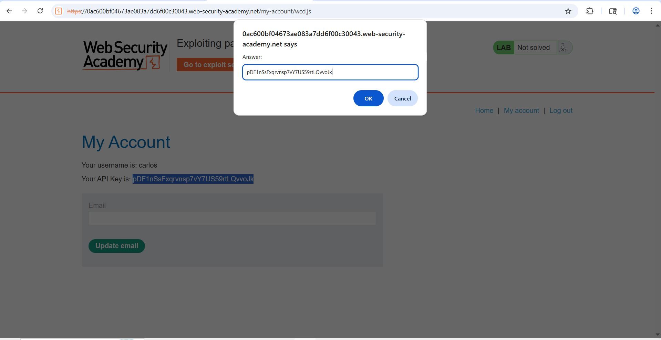

6. Impact
- Sensitive data leakage (API keys)
- Unauthorized access to user data
- Cache poisoning risks

